# OnPrintShop Setting and Updating Prices

From the admin panel go to products module and select **Products** and start entering all necessary information.

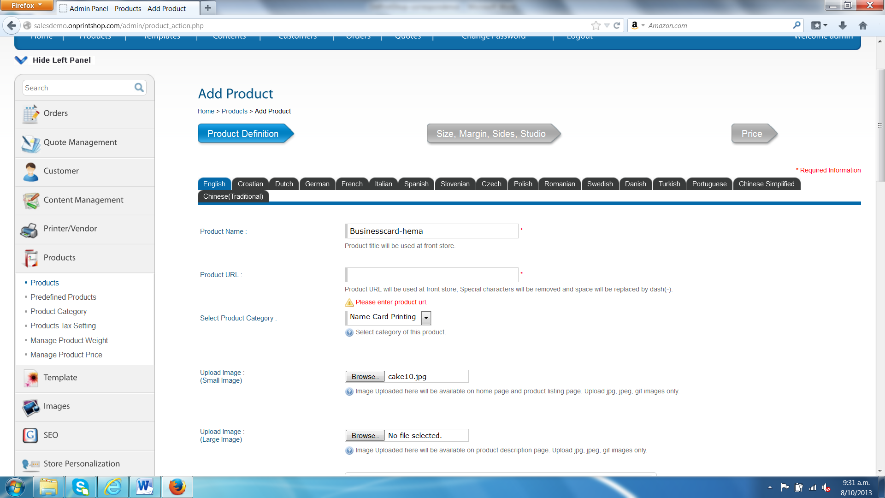

Once entered all the necessary information and click save and continue, it takes us to **Edit Designer Option** page to set designer options like page margins etc.

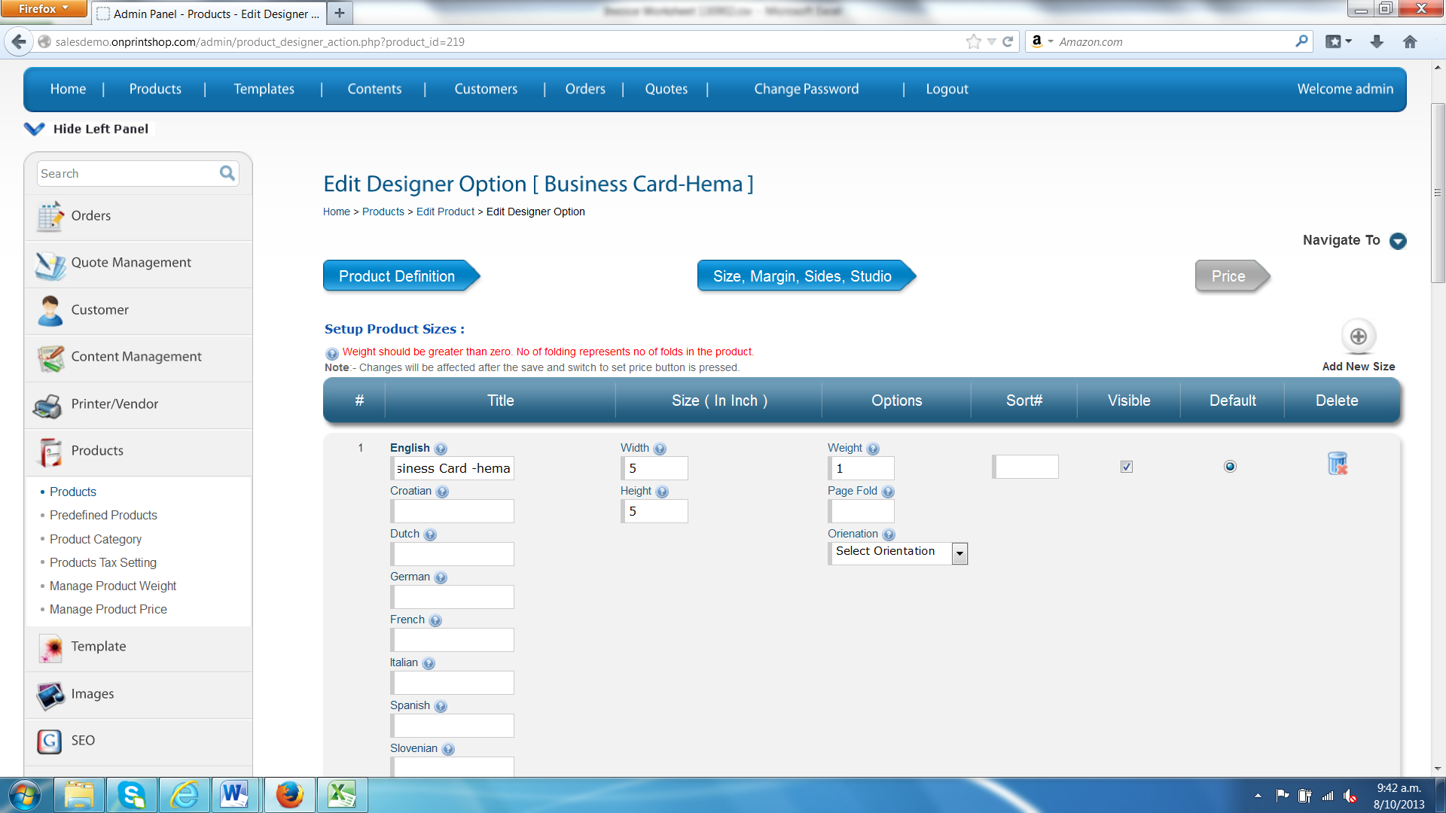



At the bottom can see three buttons, to set the price we need to click the **Save and Switch to set Price** button to continue to set the price.

We get to set the price for the retail customer, because we chose to set the price for the retail customer.

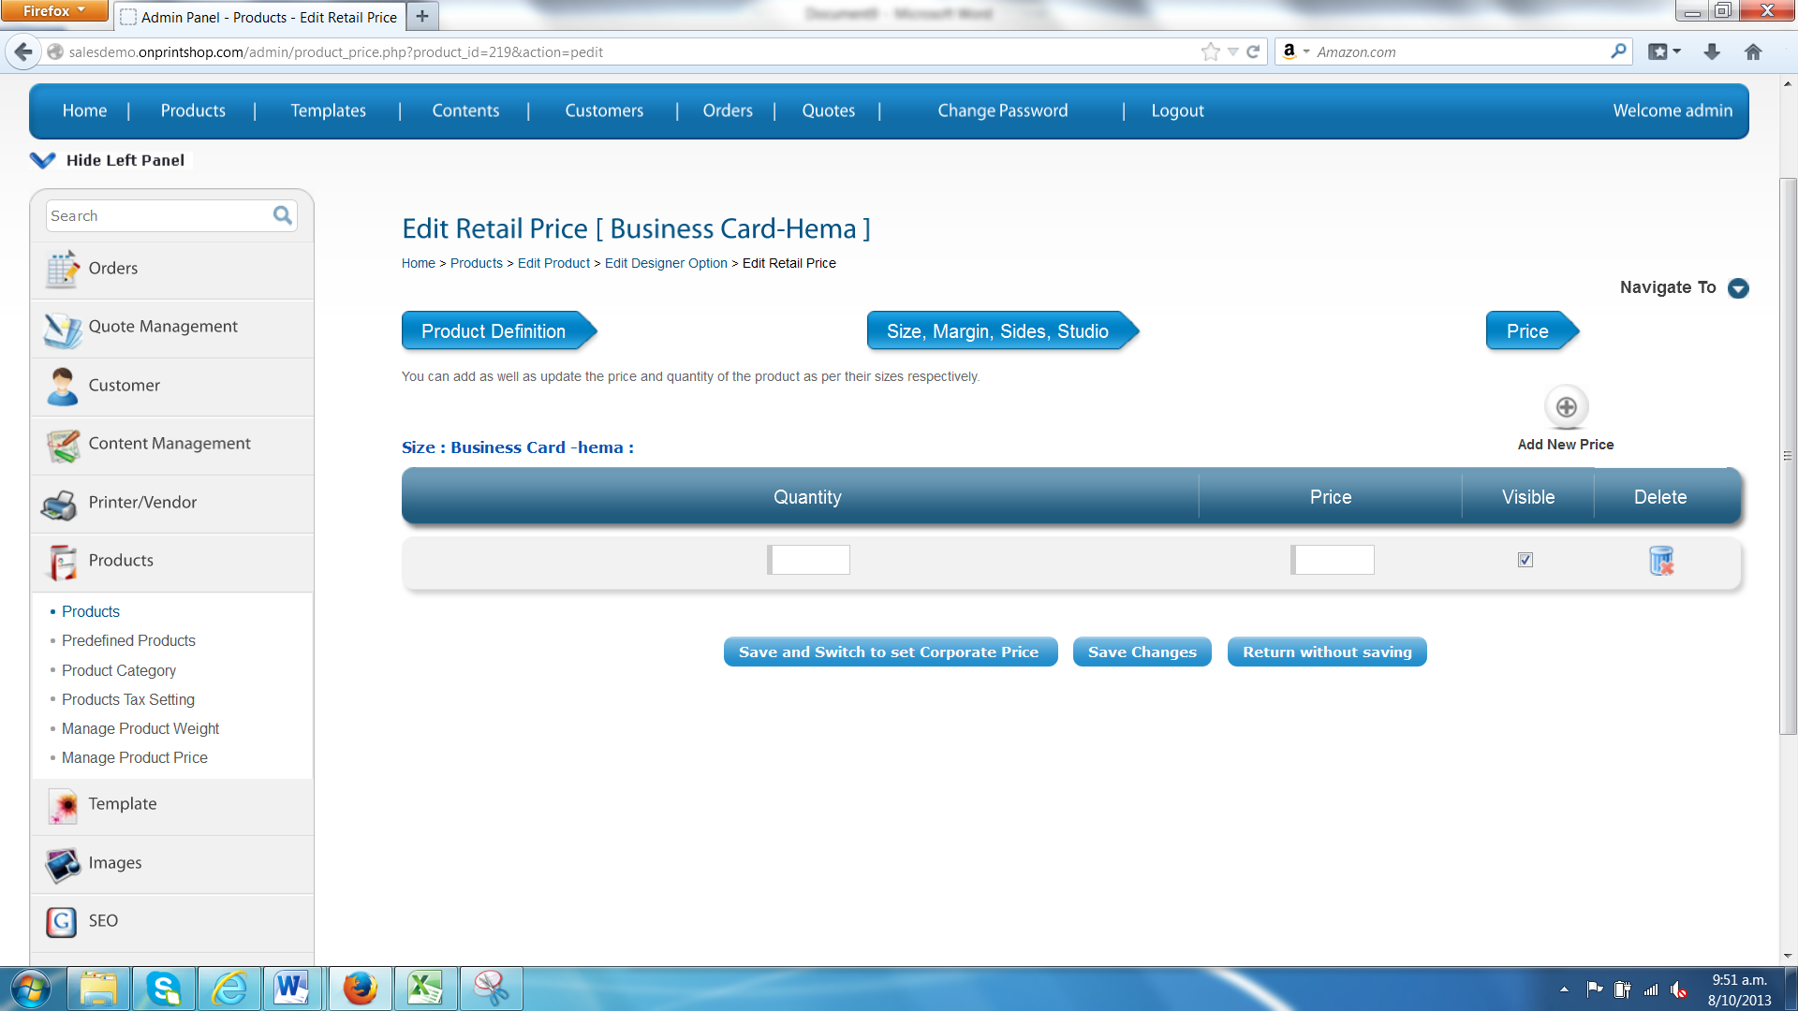

Admin can set the price for different customers in different price range.

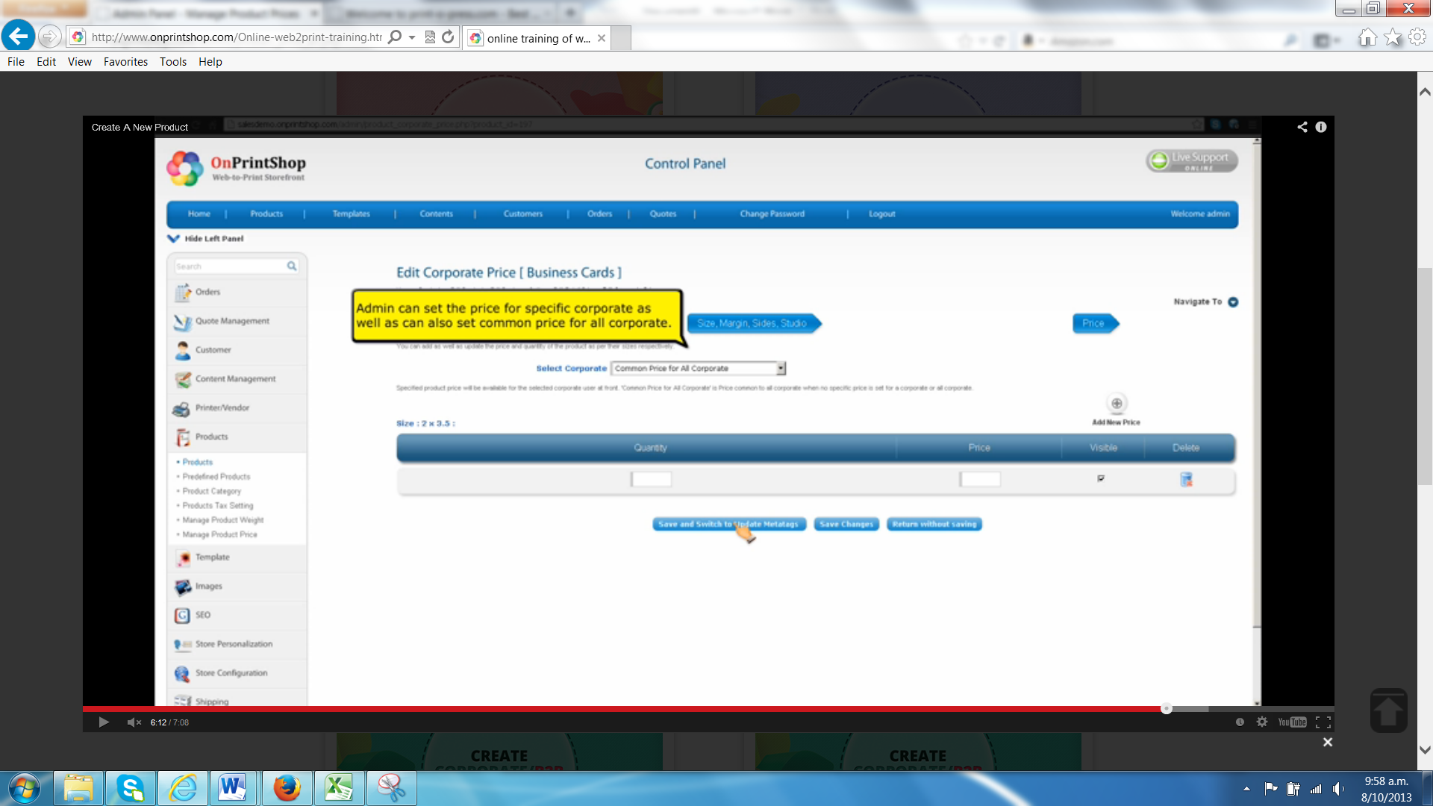

Admin can also set the price in different price calculation by going to **Manage Product Price** in **Product module.**

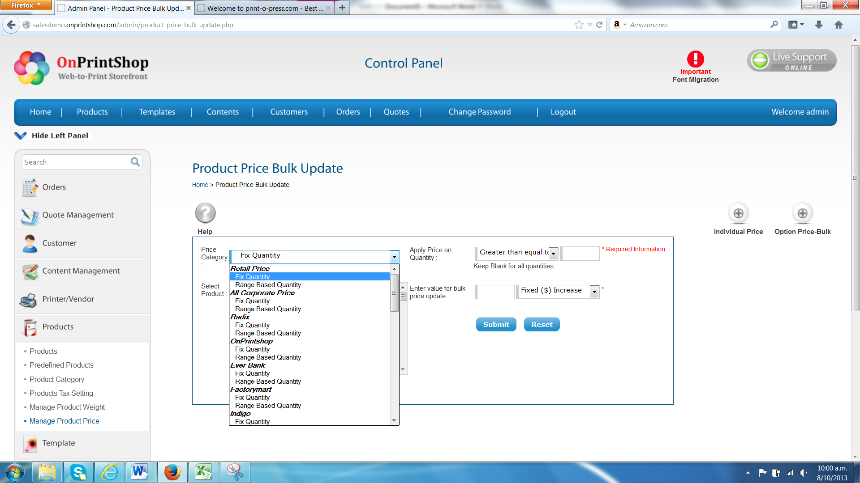

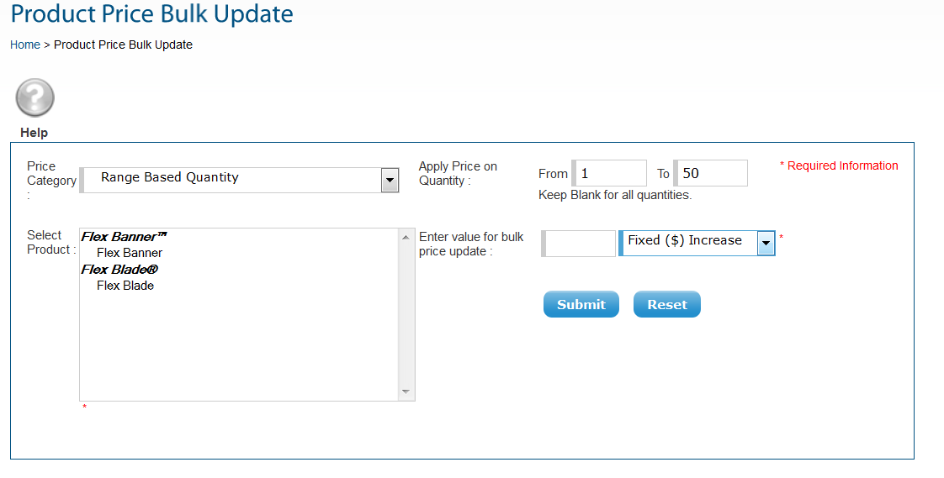

And set the price per single or bulk and let the system calculate the rest.

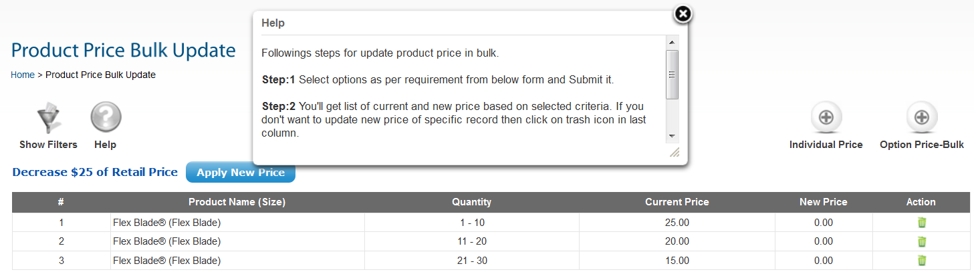

Similarly if we like to set up any particular price for particular retail customer then should be able to do it by going to **Products** module and then **manage product price,**

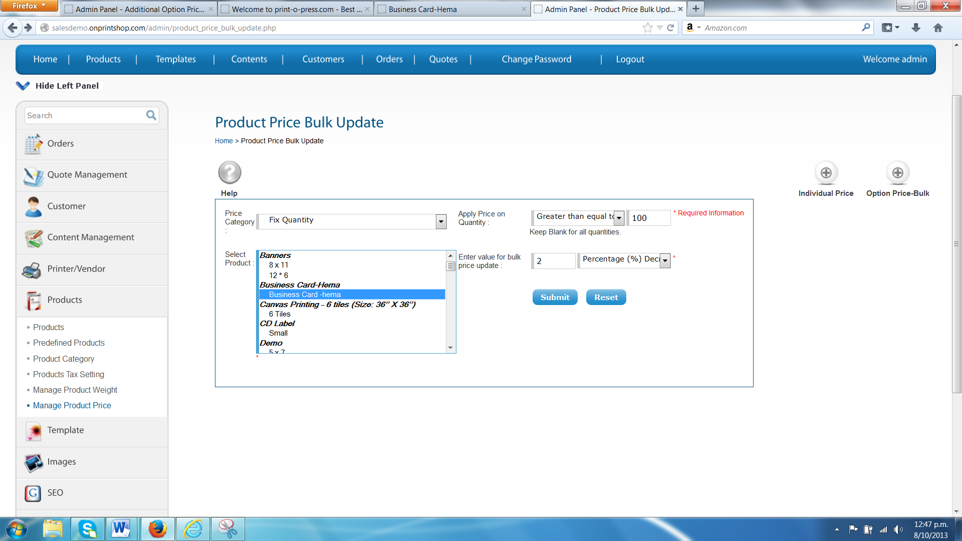

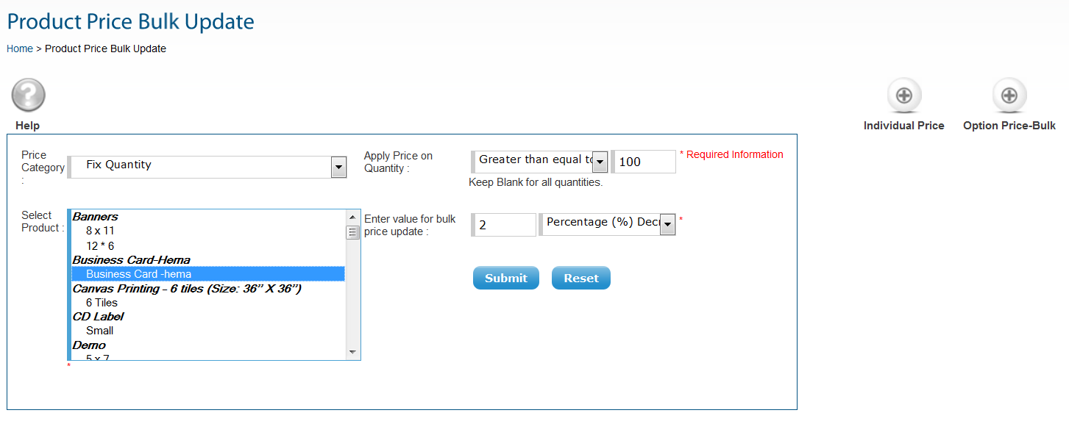

And enter the percentage of decrease then the system will calculate by itself.